Day 12 Scope and number guessing game

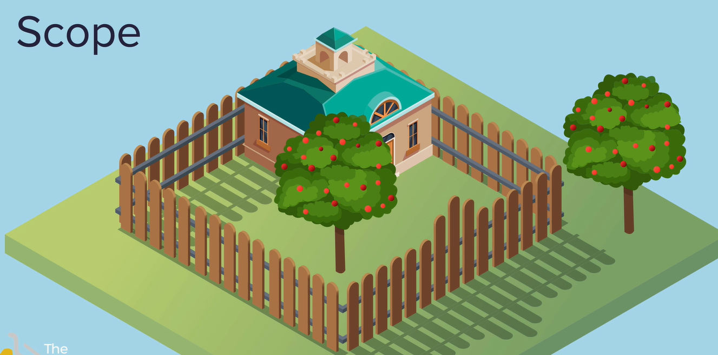

Inside or outside the fence

Local scope exists within functions 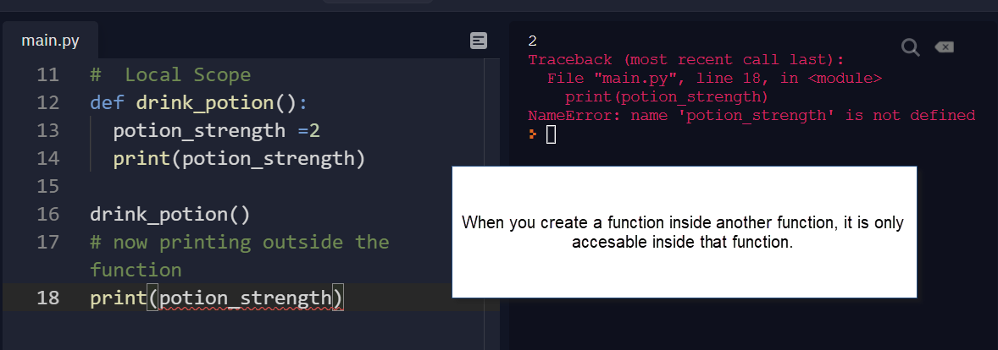

The only difference between local scope and global scope is where you define the variable. Defined at top level(not within another function) it is avalible anywhere.

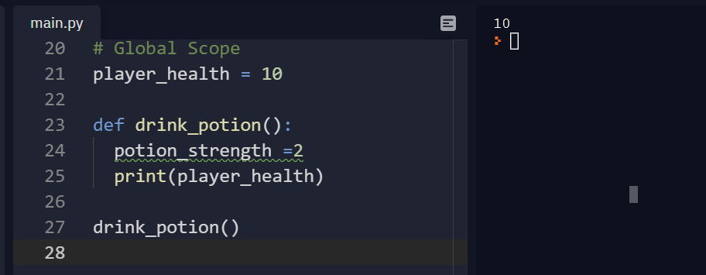

This also applies to other things -

Namespace

<https://docs.python.org/3/tutorial/classes.html#python-scopes-and-namespaces>

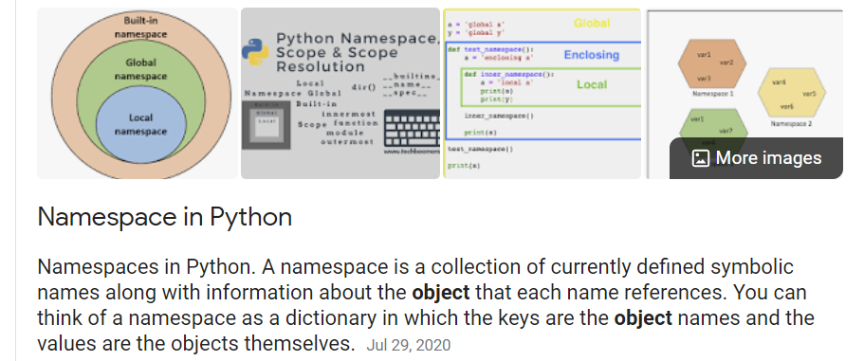

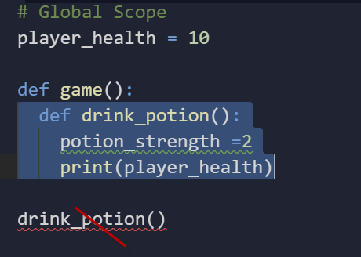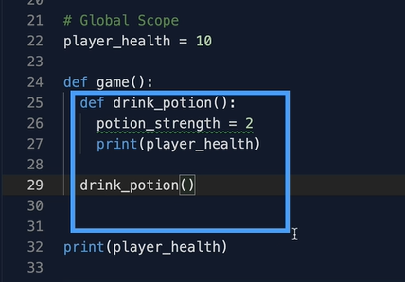

Where you write the line of code determines the scope.



If you create a new variable in an if block or for loop ect – it is not a fence – it has the same scope as its enclosing function or if no enclosing funtion it has global scope

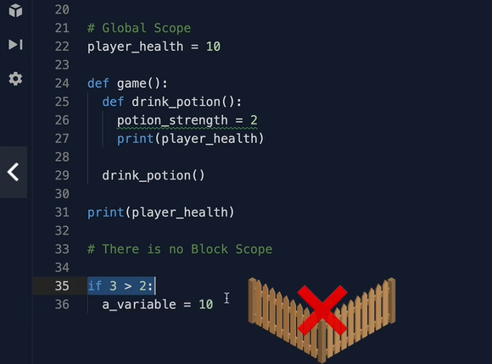

This works

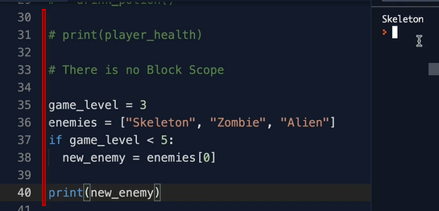

This does not work

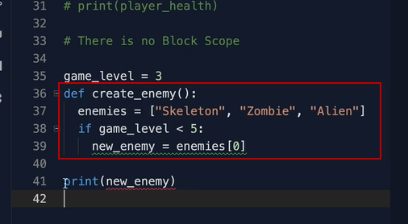

But this will work

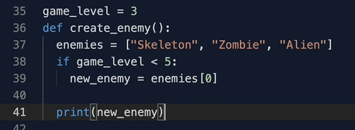



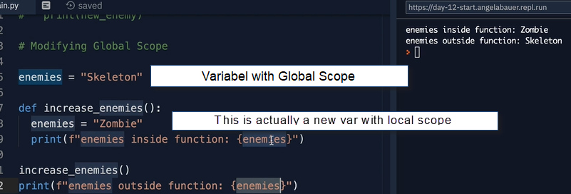

Need to explicity say the variable is global – don’t want to do this too often as it is confusing and prone to errors . Avoid modifing global scope – ok to read, but don’t try to modify in a function that has local scope.

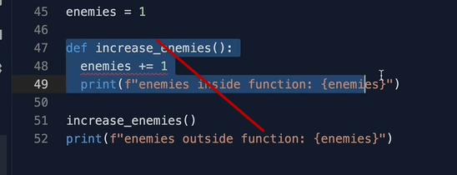

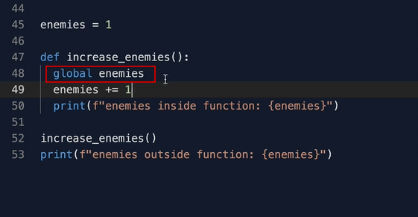

Could use return statements instead – this works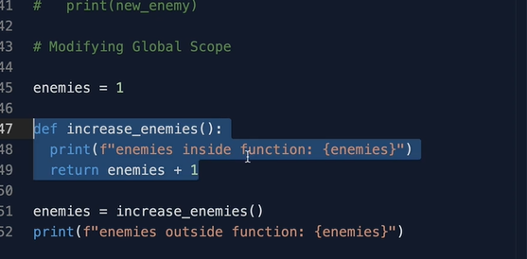



Global scope is very helpful when defineing Constatns, something that will never change.

Like pi

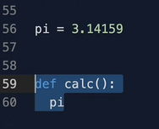

The python convention for this is to use upper case

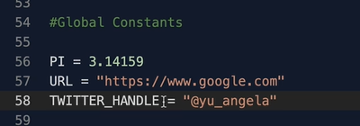

Guessing game

<http://patorjk.com/software/taag/#p=display&f=Graffiti&t=Type%20Something%20>

<http://patorjk.com/software/taag/#p=display&f=Graffiti&t=Type%20Something%20>

<http://www.pythontutor.com/visualize.html#mode=edit>